Core Game Display

GamePanel Class:
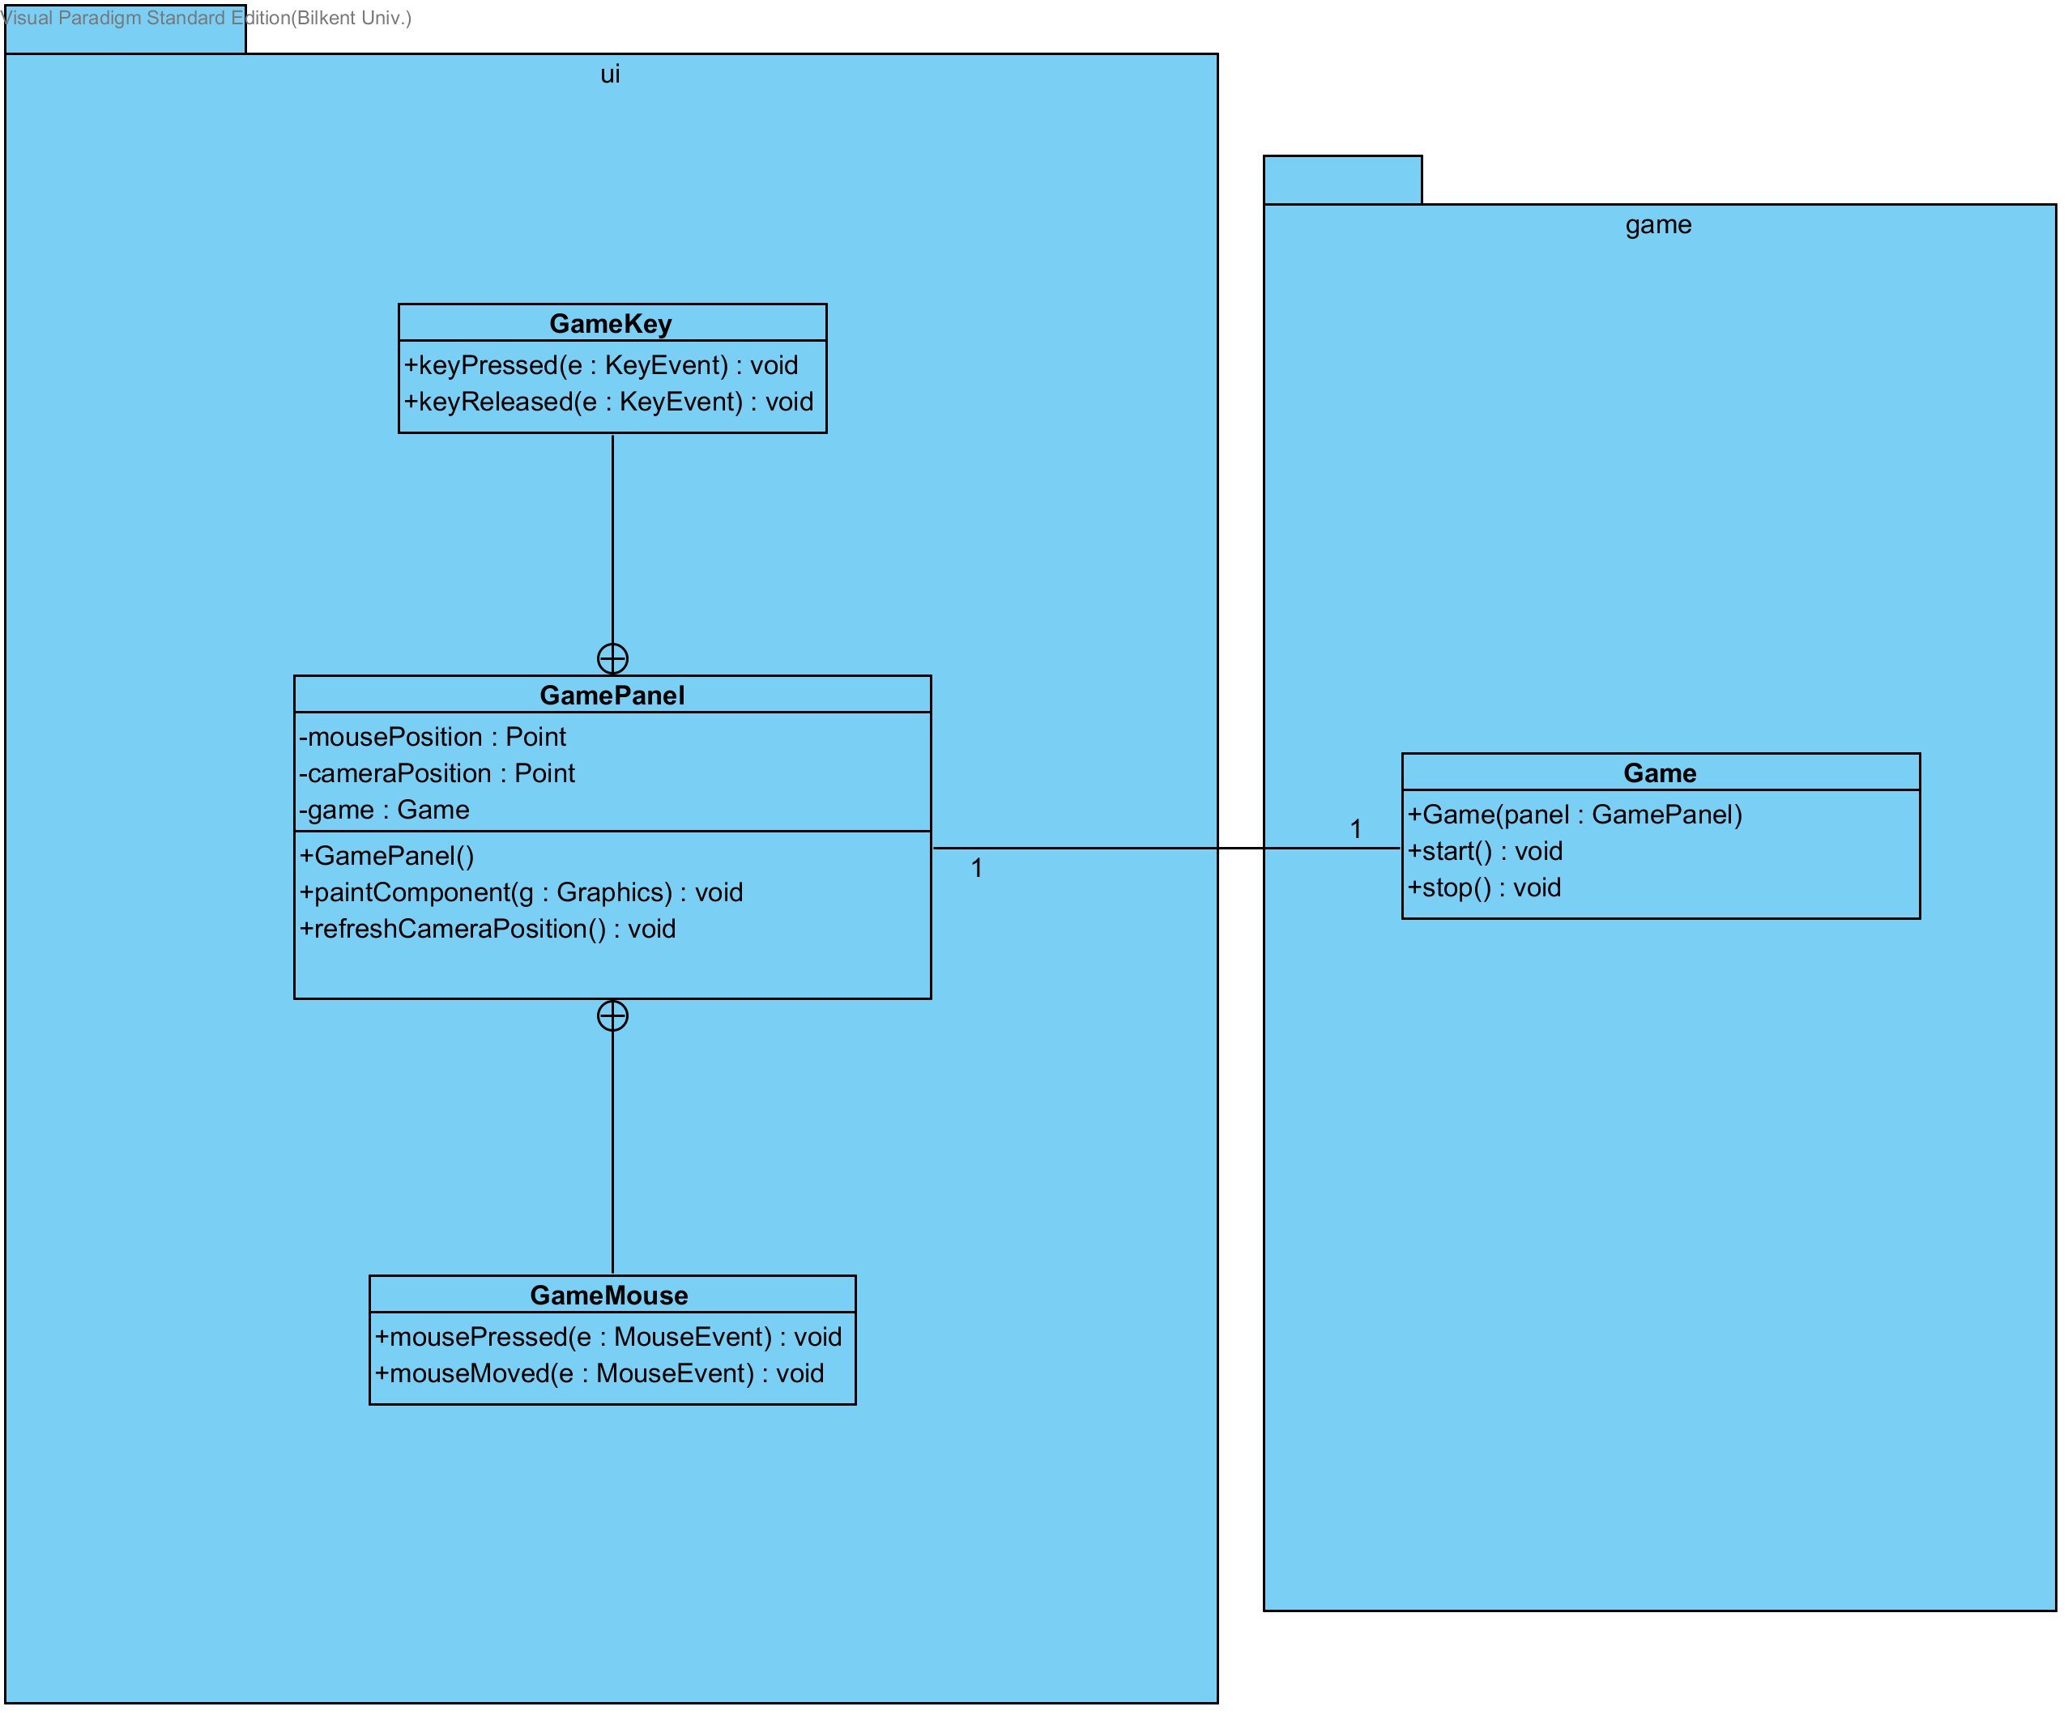
Display and input control is done by a subclass of JPanel called GamePanel. This class is responsible for displaying the elements within the game, calculate the offset of display (offset is dynamic depending on the position of the mouse cursor) and inform the game itself on any mouse click or keystroke.
refreshCameraPosition(): Calculates the position of the object drawing offset depending on the player’s position within the game and the position of the mouse cursor.

Game Class:
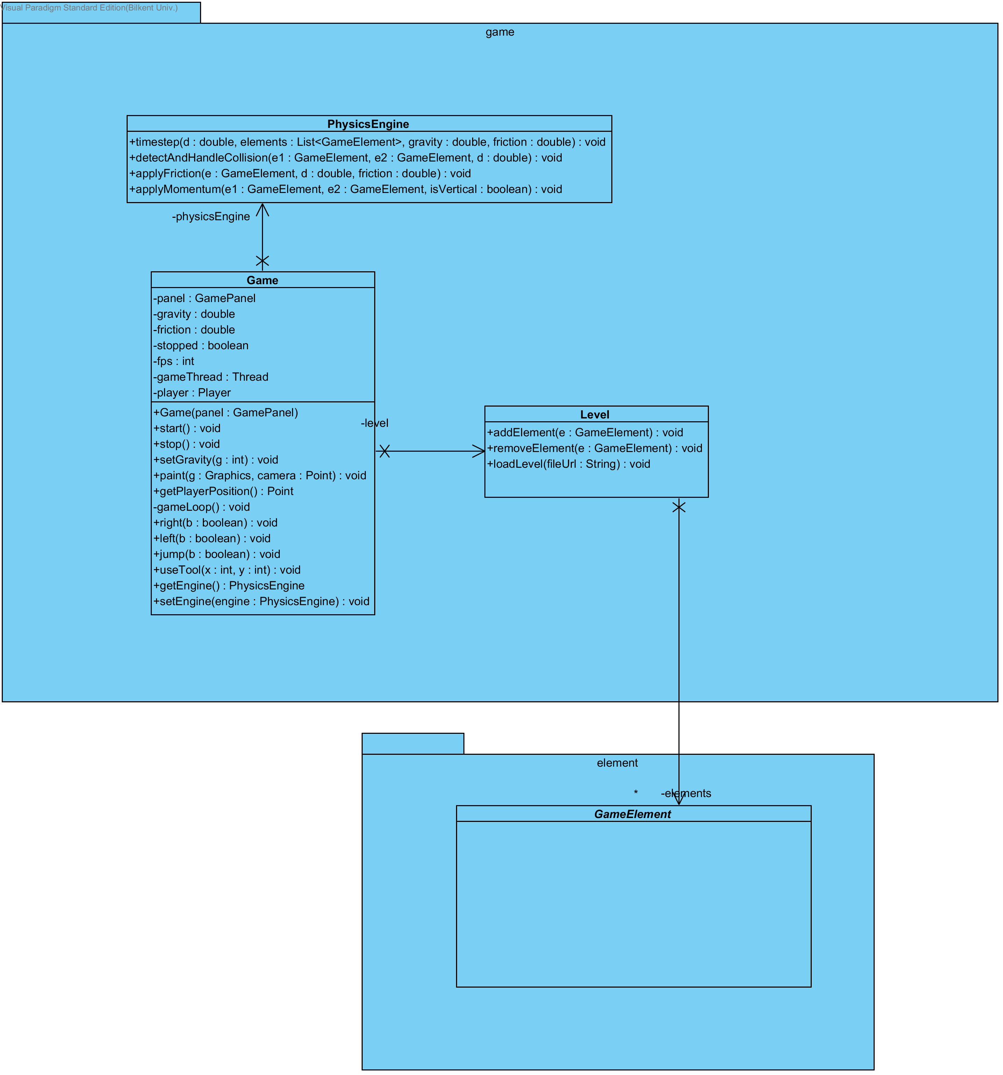
This class is responsible for executing the physics engine on a set of GameElement objects on specific time intervals. It contains a Level object which contains a list of GameElements. GameElement objects are the building block of the levels within the game. Game class periodically calls the timeStep function of PhysicsEngine class which moves the GameElements one by one depending on their existing velocities and applies gravity and friction. PhysicsEngine also handles the collisions between objects and applies momentum on collisions.
start(): This method creates a new thread and calls the gameLoop method. Since this is a never ending loop until the game is paused or the level is completed, a new thread is necessary in order to keep the other functionalities of the program going.
gameLoop(): This method creates a loop which runs the timeStep method of PhysicsEngine class once every specific time period (60 times a second by default).
stop(): Stops the engine thread, can be started again by recalling start method.

GameElement Class:
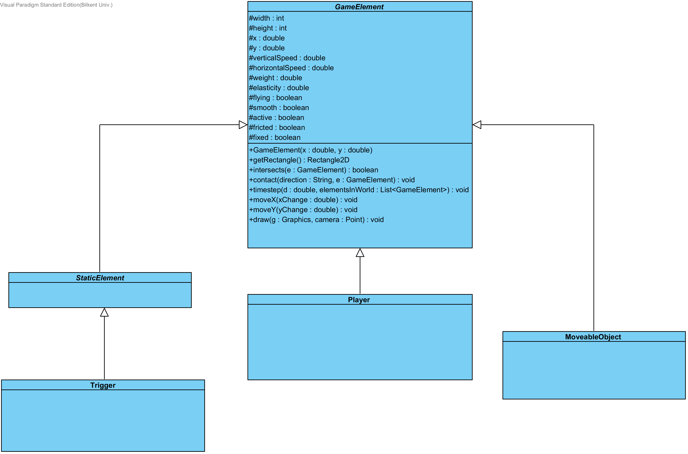
This class itself is abstract and can’t be instantiated. All elements with physical presence on a level extends this class.
x, y, width, height: Position and dimensions of this element’s rectangular area.
verticalSpeed, horizontalSpeed: Velocity of the element on specified axis.
weight, elasticity: Affects the way this object’s collisions are handled (momentum).
flying: If this property is true, this element is not affected by gravity.
smooth: If this property is false, this element will not be physically affected by collisions (But will still be informed in case it collides with another object).
active: This object will be removed from the level by the PhysicsEngine on next timestep if this property is false.
fricted: If this property is false, friction will not be applied on this object.
fixed: If this property is true, this object will not be physically affected by the PhysicsEngine but other objects will still collide with it, meaning that on ly the colliding object will be affected by the collision.
getRectangle(): All objects in the game have rectangular hit boxes. intersects method calls this method to check if there is any collision between two elements.
intersects(GameElement): Checks if the object collides with said another GameElement.
contact(String, GameElement): PhysicsEngine informs the object of the collision and gives the reference of the colliding object and gives its direction (left, right, top, bottom). It is an empty method by default, extending element can override it for element specific actions on contacts.
timestep(double, List<GameElement>): This method is called on every loop of PhysicsEngine timestep call. It is empty by default but some elements might require specific actions to be performed other than physics every timestep, it can be overridden to fulfill that possible element specific requirement.
draw(Graphics, Point): Draws the object on a given Graphics object with a given offset. Should be overridden to make sure all objects on the level look different.

StaticElement and Triggers:
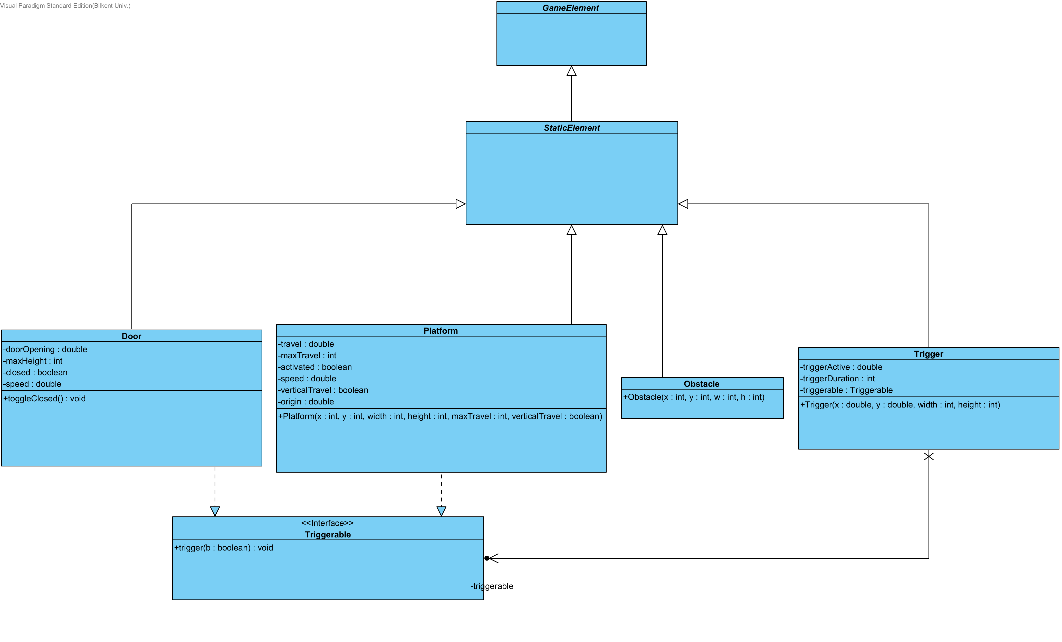
StaticElement: These objects are just implementations of GameElements which have their “fixed” property true. However this does not mean that they are stationary in the level. They do not have unpredictable movements like the Player or MoveableObject but door and platform can have a periodic predictable movement if they are triggered.
Trigger: A trigger is a non-smooth object by default. When a non-static element passes through this object, this object calls the trigger method of a set Triggerable (e.g. opening a door, raising a platform).
Triggerable: This is an interface which can be implemented by anything. It can be an element which moves accordingly when triggered or an ordinary object which may end the level when triggered.
Door: This element is a thin tall object which decreases height towards upwards when triggered. It may block the path of the player in-game, player must find a way to trigger it to get through.
Platform: This element is similar to Door but it is more complex. It can be set to move any amount of pixels and its direction and axis can be set. Its timestep function is overridden to check for any non-fixed objects and drag them with it (to ensure that a player standing on top of it during movement does not fall off).

Player Class:
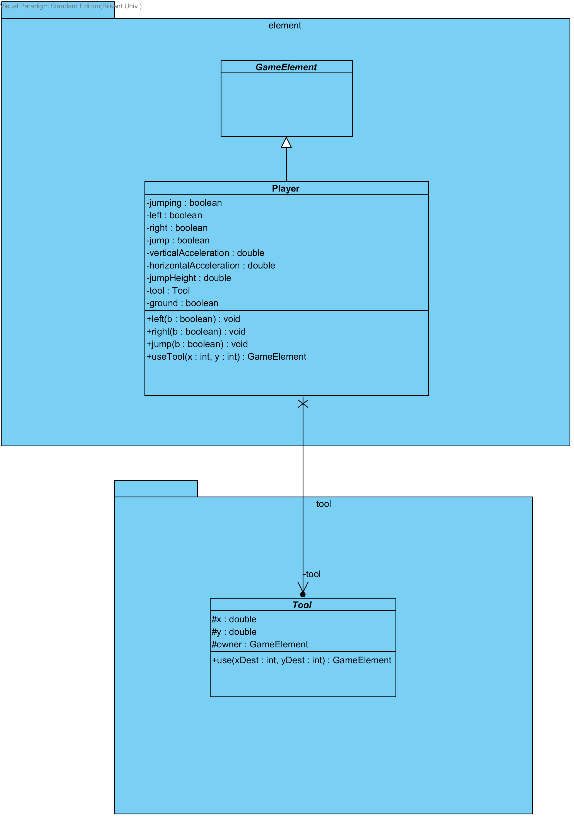
Player class is one of the most important elements in the game. This is the element which represents the main character of the game and it is directly controlled by the user. It has the ability to jump up to a set height and can run horizontally with a set speed.

